

Minecraft XBLA Release 1.3.1 Update (TU14)

TABLE OF CONTENTS

Introduction 2
Tutorial/Trial World Changes & Additions 3
Tutorial Changes & Additions 3
Trial World (Beyond Tutorial Area) Changes & Additions 3
New Features 3
Secret Chest Positions 4
How To Play Additions/Changes 5
What’s New 5
New Mobs 6
New Items & Blocks 7
Create World 8
Terrain Generation Additions 8
Bonus Chest 8
Host Options 8
UI changes & Additions 9
Anvil 9
Trading 10
Dying Armour 11
Creative Menu 12
Crafting Menu 12
Notable Gameplay Changes 13
Additional DLC updates 14

Change Table

Change | Who | Date
Initial Doc | PB | 10/01/14

Introduction

This document lists the main additions to the TU14 update, but there are many more changes in the game code itself as well as these. See http://minecraft.gamepedia.com/Version_history/Minecraft_1.3 for the full list.

Tutorial/Trial World Changes & Additions

We’ll be adding mini-tutorials for the new functionality in this update.

Tutorial Changes & Additions

There are new mini-tutorials on:-

- Anvil
- Ender Chest
- Trading with Villagers
- Riding a Pig
- Breeding (Changes to Food)
- Dying leather armour
- Dying wolf collar
- Using tripwires

The new items introduced in this version will also be placed in the tutorial world.

Trial World (Beyond Tutorial Area) Changes & Additions

New Features

The Tutorial world includes features created by the new world generation changes –

- Desert Villages
- Desert Temples
- Jungle Temples
- Carrots and Potatoes in Villages (1.4.2 feature)

The tutorial world has 12 secret chests with one of each of the twelve different music discs in each chest, along with some other items.

Secret Chest Positions

 | X | Y | Z | Disc
Chest 1 | 48 | 81 | -97 | 13
Chest 2 | -255 | 47 | -35 | Cat
Chest 3 | 210 | 71 | 93 | Where are we now
Chest 4 | -409 | 74 | 96 | Chirp
Chest 5 | 26 | 61 | 241 | Far
Chest 6 | 285 | 82 | 103 | Stal
Chest 7 | -301 | 69 | 106 | Mellohi
Chest 8 | 0 | 51 | 344 | Strad
Chest 9 | -15 | 63 | -371 | Ward
Chest 10 | 383 | 63 | -337 | Blocks
Chest 11 | 367 | 75 | -57 | 11
Chest 12 | -164 | 88 | -273 | Mall

How To Play Additions/Changes

The graphics will need updated for and changed menus and with the new items.
We’ll add a new section for the Anvil and Trading menus.

What’s New

The “What’s New” section will be changed to reflect all the new features.

New Mobs

- Zombie Villagers

New Items & Blocks

- Emerald
- Emerald Ore
- Block of Emerald
- New Golden Apple
- Ender Chest
- Tripwire Hook
- Enchanted Golden Apple
- Anvils (1.4.2 feature)
- Flower Pots (1.4.2 feature)
- Cobblestone Walls (1.4.2 feature)
- Mossy Cobblestone Wall (1.4.2 feature)
- Wither painting (1.4.2 feature)
- Potato (1.4.2 feature)
- Baked Potato (1.4.2 feature)
- Poisonous Potato (1.4.2 feature)
- Carrot (1.4.2 feature)
- Carrot on a Stick (1.4.2 feature)
- Golden Carrot (1.4.2 feature)
- Pumpkin Pie (1.4.2 feature)
- Night Vision potion (1.4.2 feature)
- Invisibility potion (1.4.2 feature)
- Nether Quartz (1.5.0 feature)
- Nether Quartz Ore
- Block of Quartz
- Nether Quartz Slab
- Nether Quartz Stairs
- Chiselled Quartz Block
- Pillar Quartz Block
- Enchanted Book
- Carpets (1.6 feature)
- Added crafting recipes for Smooth Sandstone and Chiselled Sandstone

Create World

We’ll be adding the new terrain features from the Java 1.3.1 version.

Terrain Generation Additions

The terrain generation with 1.3.1 adds the following new features:-

- Desert Villages
- Desert Temples
- Jungle Temples
- Carrots and Potatoes in Villages (1.4.2 feature)
- Emerald Ore (only generates in Extreme Hills biomes, may need changed)
- Nether Quartz Ore (in the Nether)

Bonus Chest

We’ll be adding a few items into bonus chests to allow worlds made with older versions to have access to some newer items.

Host Options

Additional options:-

- enable teleporting to players (using the back menu to bring up the list of players)
- enable flying, invisibility, invulnerability for remote players

UI changes & Additions

Anvil
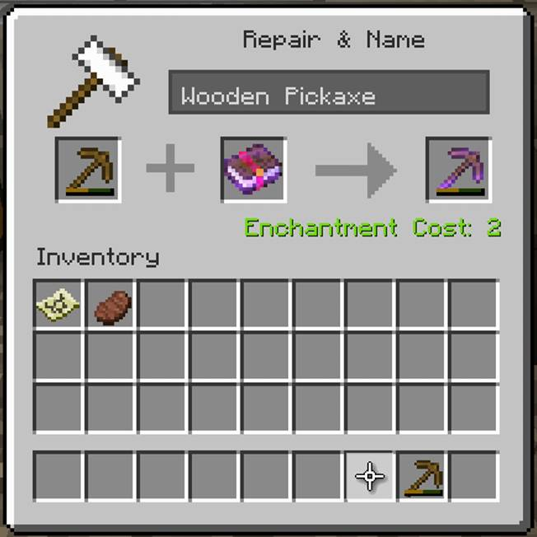

This is a new UI for the Anvil.

Trading

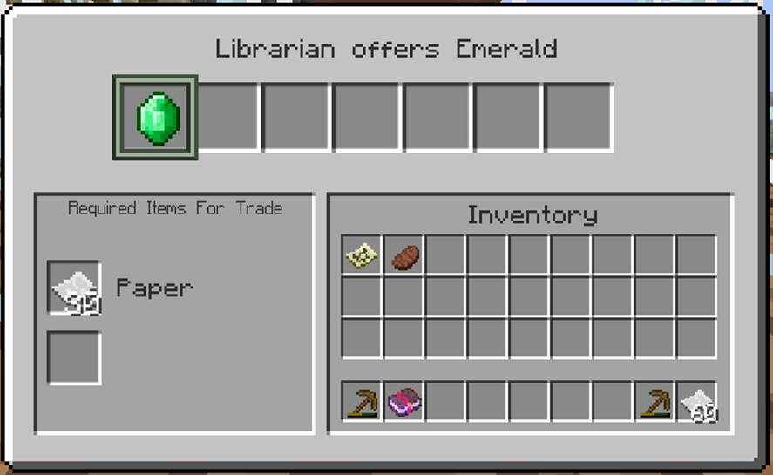

This is a new UI for trading with villagers.

Dying Armour

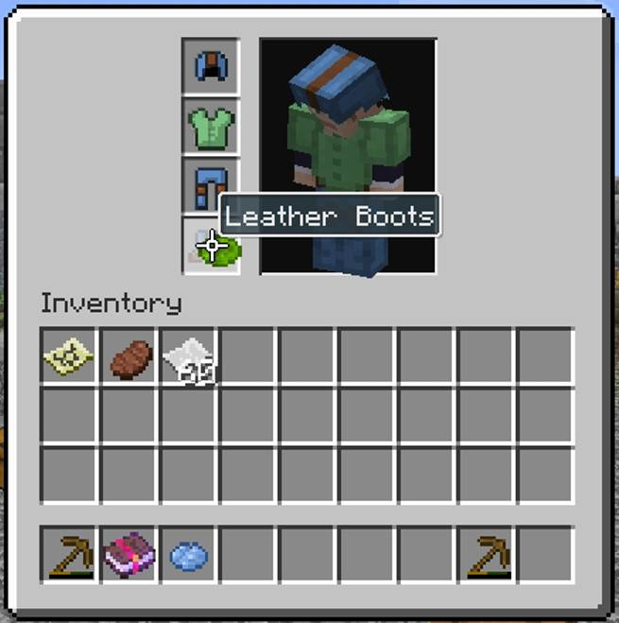

You can now dye leather armour by moving the dye over the armour and applying.

Creative Menu

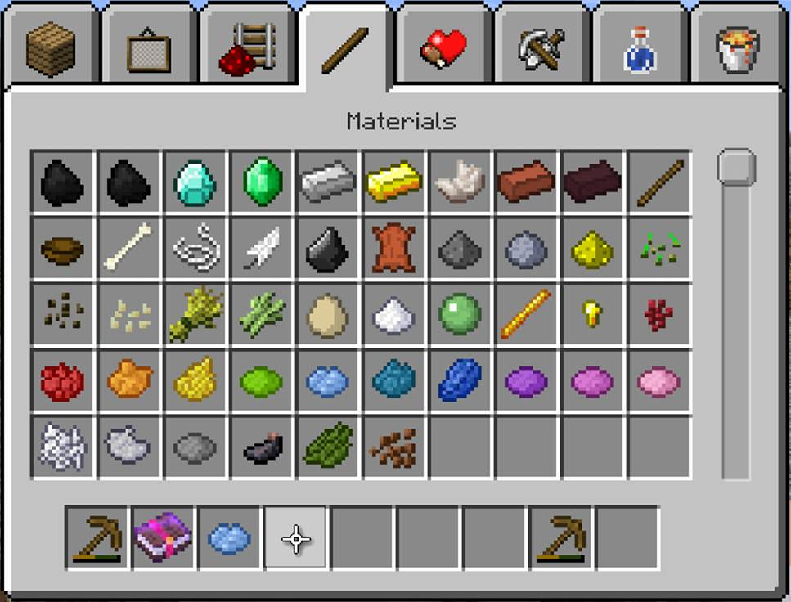

There is now a slider since there are more than 1 page of items in places. The items have been re-ordered to move to the tab that makes the most sense for them.

Crafting Menu

The layout of the crafting menu is as before, just with additional items added for TU14

Notable Gameplay Changes

- Added trading enabling buying/selling items with villagers for emeralds
- Villagers spawned from spawn eggs will have a random profession
- Logs can be places sideways
- Ice and Glass panes can be collected with silk touch enchanted tools
- Leather Armour can be dyed (1.4.2 feature)
- Wooden Buttons and Wooden Pressure Plates are activated by arrows
- Arrows on fire will set fire to mobs if they hit them
- Pigs drop saddles when killed (1.4.2 feature)
- Wolf Collars can be dyed (1.4.2 feature)
- Doors being broken by Zombies show damage
- Furnace can use wooden tools as fuel
- Furnace will return an empty bucket when a bucket of lava is used as fuel
- Ice melts in the Nether
- Cauldrons fill in the rain
- Changes to placing upside-down stairs, and half blocks

Additional DLC updates

We will incorporate these changes in to the game, rather than updating DLC.

- Texture packs - additional textures for all new items, changes to UI, and updates for How To Play sections.

